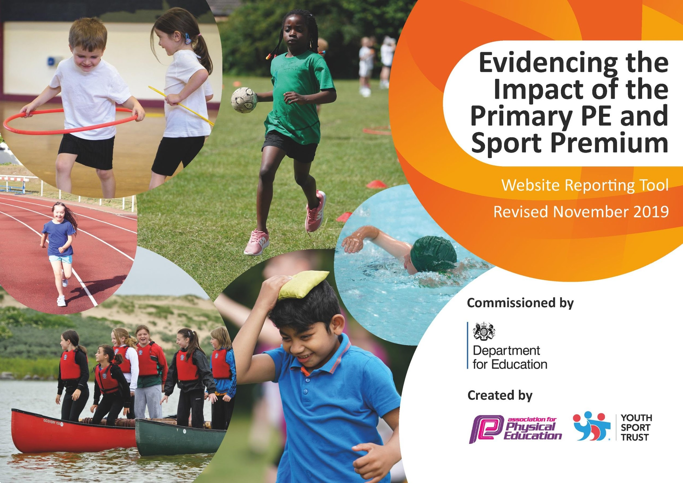
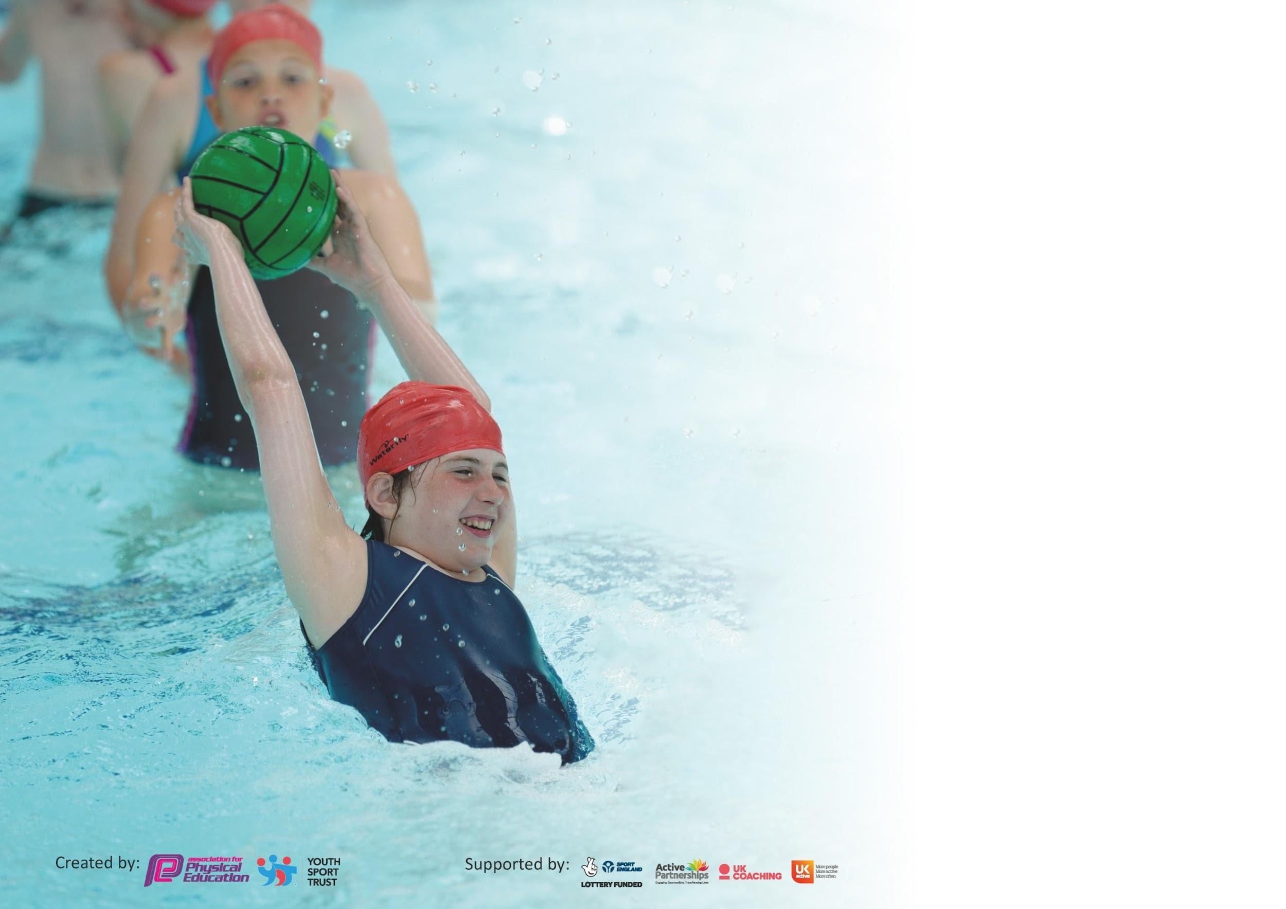

It is important that your grant is used effectively and based on school need. The Education Inspection Framework (Ofsted 2019 p64) makes clear there will be a focus on ‘whether leaders and those responsible for governors all understand their respective roles and perform these in a way that enhances the effectiveness of the school’.

Under the Quality of Education criteria (p41) inspectors consider the extent to which schools can articulate their curriculum (INTENT), construct their curriculum (IMPLEMENTATION) and demonstrate the outcomes which result (IMPACT).

To assist schools with common transferable language this template has been developed to utilise the same three headings which should make your plans easily transferable between working documents.

Schools must use the funding to make additional and sustainable improvements to the quality of Physical Education, School Sport and Physical Activity (PESSPA) they offer. This means that you should
use the Primary PE and Sport Premium to:

- Develop or add to the PESSPA activities that your school already offer
- Build capacity and capability within the school to ensure that improvements made now will benefit pupils joining the school in future years

Please visit gov.uk for the revised DfE guidance including the 5 key indicators across which schools should demonstrate an improvement. This document will help you to review your provision and to report your spend. DfE encourages schools to use this template as an effective way of meeting the reporting requirements of the Primary PE and Sport Premium.

We recommend you start by reflecting on the impact of current provision and reviewing the previous spend.

Schools are required to publish details of how they spend this funding as well as on the impact it has on pupils’ PE and sport participation and attainment by the end of the summer term or by 31st July 2020 at the latest.

We recommend regularly updating the table and publishing it on your website throughout the year. This evidences your ongoing self-evaluation of how you are using the funding to secure maximum, sustainable impact. Final copy must be posted on your website by the end of the academic year and no later than the 31st July 2020. To see an example of how to complete the table please click HERE.

Support for review and reflection - considering the 5 key indicators from DfE, what development needs are a priority for your setting and your pupils now and why? Use the space below to reflect on previous spend and key achievements and areas for development.

Key achievements to date until July 2019: | Areas for further improvement and baseline evidence of need:
- 20 % of year 5 pupils are now Sport’s Leaders at lunchtime and playtimes.  - An assessment system has been put in place for swimming and P.E to support planning and delivery.  - High quality CPD has been provided for all teachers and AT’s across school to develop their confidence in delivering high quality PE through the use of observing highly trained coaches and delivering team teach lessons alongside the PE specialist. Chance to Shine Cricket/York City Knights/British Judo were all used to help deliver the lessons.  - All pupils have been provided with a free PE kit in a bid to raise standards and raise the pupils self-esteem by making pupils feel proud to be part of a team (this links closely to the schools key virtue of belonging).  - All Pupils can travel to competitions after school for free so there are no barriers for any pupil not to participate in sporting events.  - Haxby Road primary academy offers two hours of high quality P.E lessons to ALL pupils from Tiny Steps to YEAR 6 (2-11) each week and the PE curriculum ensures skills are progressive.  - We continue to provide a range of sports teams across school, these include football, netball, athletics, cricket, Tag Rugby.  - Pupils are still continually competing in many sports at level 2 against other schools in York and across EBOR academies this year (7 competitions attended this year  - Successful partnership with York St John University in place for a number of years. This year we successfully organised and ran our first ever multi skills after school club for KS1 with parental engagement at the heart of it, at York St John University. Fully qualified York St John students ran the clubs, with seniors leaders over seeing the club | - To continue to develop the expertise and knowledge of the Sport’s Leaders and train new year 5 leaders into their roles in order to continue to promote active play and lunch times.  - To continue to provide high quality CDP to all staff to ensure the delivery of PE continues to be high quality and sustainable for all children.  - To continue to raise the profile of sport and active lifestyle within the school community.  - PE Specialist to continue to develop staff knowledge of early movement and progression of key skills for key groups of children: SEND, PP and CLA to continue to raise the profile of PE for these groups through the use of York St John University.  - To continue to embed fit for 30 across school.  - To increase the percentage of children engaged in competitive sports and activities across all year groups.  - To identity and develop sporting talents.  - To raise the attainment in primary school swimming and ensure ALL pupils leave primary school able to swim.

Meeting national curriculum requirements for swimming and water safety.
What percentage of your current Year 6 cohort swim competently, confidently and proficiently over a distance of at least 25 metres?  N.B. Even though your pupils may swim in another year please report on their attainment on leaving  primary school at the end of the summer term 2020. | At the moment we are on 94% (spring 2019) - Due to Covid19, we are currently unable to swim
What percentage of your current Year 6 cohort use a range of strokes effectively [for example, front crawl, backstroke and breaststroke]? | 89%
What percentage of your current Year 6 cohort perform safe self-rescue in different water-based situations? | 84%
Schools can choose to use the Primary PE and Sport Premium to provide additional provision for swimming but this must be for activity over and above the national curriculum requirements. Have you used it in this way? | No

Action Plan and Budget Tracking
Capture your intended annual spend against the 5 key indicators. Clarify the success criteria and evidence of impact that you intend to measure to evaluate for pupils today and for the future.

Academic Year: 2019/20 | Total fund allocated: £17760 | Date Updated: 10.6.20
Key indicator 1: The engagement of all pupils in regular physical activity – Chief Medical Officer guidelines recommend that primary school pupils undertake at least 30 minutes of physical activity a day in school |  |  |  | Percentage of total allocation:
 |  |  |  | 26%
Intent | Implementation |  | Impact
Your school focus should be clear what you want the pupils to know and be able to do and about  what they need to learn and to  consolidate through practice: | Make sure your actions to achieve are linked to your intentions: | Funding allocated: | Evidence of impact: what do pupils now know and what can they now do? What has changed?: | Sustainability and suggested next steps:
Our focus is to provide all pupils with fundamental movement skills, enhancing their physical literacy with a key focus on SEND (ERP), LAC and PP groups. We have also recognised the importance of social and emotional needs of pupils from an early age. By providing pupils with this opportunity at an early age, we will see happy well-rounded individuals throughout KS1. | - Audit of resources to take place in line with curriculum map and the children’s needs. High quality resources purchased to develop basic skill progression in….  - Daily sensory circuit equipment purchased for key groups of children with the aim to focus concentration and increase their readiness to learn, as well as improving balance and coordination. The sensory circuits will also develop the children’s social interactions, communications skills and abilities to work as a team | £3500 sporting equipment  Sensory circuit equipment £500 | Key group: SEND, CLA: A lot of our children are inactive at home and find playtimes difficult and therefore the use of activity exercise spots have encouraged independent exercise, and the use of the YPO Racket and Ball Skills Kit, Croquet Kit, Speed Agility Kit and Badminton/Mini Tennis Set in PE sessions have helped to develop key physical skills: learning to skip with a rope, jumping, hopping, balancing and throwing. | To continue to build capacity and capability within the school with a key focus on EYFS to ensure that improvements made now will benefit pupils joining the school.
To continue to embed fit for 30 across school and ensure children can confidently articulate the importance of a healthy mind and body. | The ‘Fit for 30’ agenda will be supported by additional resources and will provide support play, lunch and after school times. | £650 | 85% of children in KS 2 and 1 said that they were happier since doing fit for 30 and their self esteem has improved.  “I feel energised after completing our daily fitness” Year 6 pupil.  “Daily fitness is really important, not only for our physical health but also our well being! I really look forward to my daily fitness at 3pm!”  Year 5 pupil.  “Daily fitness has given me extra focus, so that I'm ready for my enrichment lessons.  year 5 pupil. | Continue to promote our daily fitness with new creative ways to keep children enjoying active lessons.
Key indicator 2: The profile of PESSPA being raised across the school as a tool for whole school improvement |  |  |  | Percentage of total allocation:
 |  |  |  | 6%
Intent | Implementation |  | Impact
Your school focus should be clear what you want the pupils to know and be able to do and about  what they need to learn and to  consolidate through practice: | Make sure your actions to achieve are linked to your intentions: | Funding allocated: | Evidence of impact: what do pupils now know and what can they now do? What has changed?: | Sustainability and suggested next steps:
To raise the profile of sport and activity across the school and the school community to ensure sustainability of a healthy lifestyle for all children.  To ensure children are self motivated to participate in a range of sporting events. | Year 6 children to train year 5 children in becoming play leaders. To develop a program of peer mentoring across school.  MSA half day training provided by PE specialist to discuss children’s needs at lunch times. Audit of timetabled active events and equipment evaluated. Training of key active games provided by the specialist using the new resources to ensure all children are active during lunch time.  Purchase Ipad for the sports specialist to ensure sporting events and competitions can be promoted and celebrated on facebook, twitter and google classroom.  IPAD used to film team teach lessons and discuss with the teacher/AT strengths and areas for development with the teaching of high quality PE.  Half termly newsletter to celebrate sporting successes within school and sign post parents to sporting clubs and competitions.  York st john  events | £250  £500  £355 | Having the sports leaders out at playtime/ lunchtime is having a real positive effect on all key stages, especially key stage 1. helping with promoting active/healthy lifestyle, emotional  resilience and understanding the importance of winning and losing.  “ I really enjoy the fun games the year 6 sports leaders play at lunchtime” year 1 pupil.  “I've learnt so much from the year 6 sports leaders, i can't wait to receive my sport leader hoodie,”  year 5 pupil (trainee sports leader)  The children’ s self esteem and confidence has been raised due to the sports clubs and play/lunchtime activities.Parents are now sending their children to sporting clubs within the community. | To continue to raise the profile of school sport and daily exercise throughout the school and within the wider community.  To continue to research the benefits of new sports and activities on the impact of children’s physical development and mental health.

Key indicator 3: Increased confidence, knowledge and skills of all staff in teaching PE and sport |  |  |  | Percentage of total allocation:
 |  |  |  | 42%
Intent | Implementation |  | Impact
Your school focus should be clear | Make sure your actions to | Funding | Evidence of impact: what do | Sustainability and suggested
what you want the pupils to know | achieve are linked to your | allocated: | pupils now know and what | next steps:
and be able to do and about | intentions: |  | can they now do? What has
what they need to learn and to |  |  | changed?:
consolidate through practice:
Hire specialist coaches to deliver high quality training in key sporting activities to work alongside staff to develop their subject knowledge and progression if skills,  PE specialist to train AT’s in key sports to enable them to effectively deliver high quality after school provision.  Ebor subject specialist to support PE specialist | Coaches not only teach staff, but also offer CPD tuition to help teachers/TA’s plan and execute effective lessons.  Google Drive has been created which supports all staff with planning, delivery and assessment of key skills and the progression. The drive provides a wealth of resources to help staff deliver PE.  Team Teach Term 1: PE specialist timetable in place across the week tailored to each teachers’ individual needs and sessions delivered together.  Ebor PE leadership network events attended.  High quality training and expertise developed. | £1000  ASC PE specialist support and  training £4656  £1000  AT cover £800 | “I now feel more confident in delivering P.E than I did before. Having these CPD courses has meant that i feel competent in delivering lessons at a high standard, knowing the children are going to learn and improve”  T.A in key stage 2  “Really enjoyed having the external sports specialist in from chance to shine and york city knights rugby - i didn't realise there were so many fun games you can do , whilst using very little equipment. learnt so many helpful tips - from organisation of area to drip feeding techniques so its manageable for the children.  great fun!”  T.A key stage 1  Sustainably improvement of provision in place for all staff. | CPD meetings -To make sure staff feel supported- continue to have termly feedback on performance - how they feel p.e lessons/lunchtimes are going. to help with this- staff team teaching sessions with the p.e specialist and each other will happen.
Key indicator 4: Broader experience of a range of sports and activities offered to all pupils |  |  |  | Percentage of total allocation:
 |  |  |  | 6%
Intent | Implementation |  | Impact
Your school focus should be clear | Make sure your actions to | Funding | Evidence of impact: what do | Sustainability and suggested
what you want the pupils to know | achieve are linked to your | allocated: £17760 | pupils now know and what | next steps:
and be able to do and about | intentions: |  | can they now do? What has
what they need to learn and to |  |  | changed?:
consolidate through practice:
To increase opportunities for ALL pupils, for participation within extra curricular clubs with a key focus on PP, SEND and CLA. | Purchased new equipment and train staff to ensure they understand the skill progression in the new sports.  Pupil voice questionnaire for CLA, PP and SEND to ensure sports are provided that match their interests and motivate them to take part in sporting clubs and events. | £1, 099 | we have found by increasing the options of our sports clubs within our enrichment -has meant that the number of children attending our clubs has increased by 25% (ks1&2). We have also been monitoring children who tend to be less active - these children are now participating in our after-school sports clubs. Teachers have also commented on a wider benefit -speaking to teachers it seems to enhance their children's academic achievement in class, as well as their mental wellbeing - increasing self-esteem and anxiety “ Since going to archery club, i've noticed a huge difference in a particular boys confidence and motivation to succeed in class.” | using pupil voice -continue to run a variety of sports clubs to appeal to a wider audience  .

Key indicator 5: Increased participation in competitive sport |  |  |  | Percentage of total allocation:
 |  |  |  | 19%
Intent | Implementation |  | Impact
Your school focus should be clear | Make sure your actions to | Funding | Evidence of impact: what do | Sustainability and suggested
what you want the pupils to know | achieve are linked to your | allocated: | pupils now know and what | next steps:
and be able to do and about | intentions: |  | can they now do? What has
what they need to learn and to |  |  | changed?:
consolidate through practice:
Purchased York School Sports Partnership (YSSP) to all the competitions in the york area to provide all pupils with as much opportunity to compete in a range of sporting events. | Attend meetings and develop competitions for ALL age groups.  Organising and facilitating a number of tournaments  Year 1-6 experienced a range of competitions outside of school as well as intra competitions. | York schools sports network (YSSN) 2019/2020  Level 2 £2950  Minibus fuel £500 | pupils from ks1-ks2 have benefitted from a range of competitions, with many more to come until the end of the summer. (unfortunately due to Covid 19 this has been put on hold) The profile of sport has been raised throughout school.  Pupil Voice: children are confident and proud to represent HRPA. This year.  “It's been a privileged to represent  haxby road in so many competitions, really going to miss it when i do eventually leave”  year 6 pupil.  “I really can't wait to be part of the sports teams”  Year 5 pupil | Review the competitions that we have attended- have they been successful?  What sports do we need to improve on.  what sports haven't we tried, that we would like to do next year.  To hold more in house events.  To continue to develop the children’s aspirations and experiences by taking them on sporting school trips  i.e. match day experience or elite sporting events

Signed off by
Head Teacher: | L Woodward
Date: | 20.6.20
Subject Leader: | T Robinson
Date: | 20.6.20
Governor:
Date:

